Project title: Methods of exceptions.
1. Aim / Objective
To implement and demonstrate Java exception-handling methods using try, catch, finally, throw, and throws.
2. System Requirements
- Hardware: Computer with minimum 4 GB RAM.
- Software: Windows / Linux / Ubuntu.
- Language: Java.
- IDE: Eclipse / VS Code / Notepad.
- JDK: Java Development Kit.
3. Algorithm
- Start the program.
- Create a class named Main.
- Use a try block to execute statements that may cause an exception.
- Use a catch block to handle the exception.
- Use a finally block to execute statements regardless of whether an exception occurs.
- Demonstrate the throw keyword to explicitly throw an exception.
- Demonstrate the throws keyword to declare a possible exception.
- Display the exception messages.
- Stop the program.
4.uml diagram:
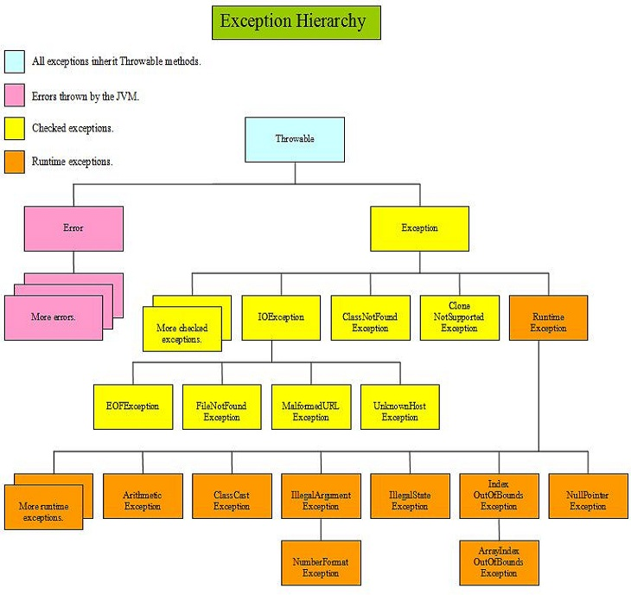
5. source code:

public class Main {

static void checkAge(int age) {
if (age < 18) {
throw new IllegalArgumentException(
"Age must be 18 or above");
}
System.out.println("Eligible");
}

static void divide() throws ArithmeticException {
int a = 10, b = 0;
System.out.println(a / b);
}

public static void main(String[] args) {

// try and catch
try {
int a = 10 / 0;
} catch (ArithmeticException e) {
System.out.println("Exception: " + e);
}

// finally
finally {
System.out.println("Finally block executed");
}

// throw
try {
checkAge(15);
} catch (IllegalArgumentException e) {
System.out.println("Throw: " + e.getMessage());
}

// throws
try {
divide();
} catch (ArithmeticException e) {
System.out.println("Throws: " + e);
}

System.out.println("Program completed");
}
}
6. Sample Output
Exception: java.lang.ArithmeticException: / by zero
Finally block executed
Throw: Age must be 18 or above
Throws: java.lang.ArithmeticException: / by zero
Program completed.
7.Compilation and Execution
Compile:
javac Main.java
Run:
java Main
8. output
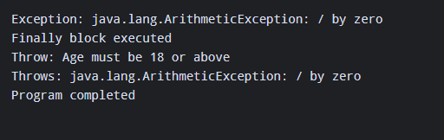
Result:
Thus, Java exception-handling keywords and methods were successfully implemented and executed to handle runtime errors and display exception messages.

